Differentiating Cognitive Strain from Passive Disengagement: A Dual-Axis EEG Analysis of Objective Complexity vs. Subjective Confusion

Mihika Saraf

- Abstract

Accurate cognitive state monitoring remains a critical challenge in asynchronous digital learning environments. While traditional tracking metrics assume a uniform physiological response to difficult educational content, this study demonstrates a profound divergence between external material difficulty (objective complexity) and internal student comprehension (subjective confusion). Utilizing a single-channel consumer EEG architecture, we developed a robust, automated blink-detection pipeline based on a dynamic $Mean+3×SD$ voltage thresholding algorithm to analyze eye-blink frequency shifts. Our analysis reveals a dual-axis behavioral profile: objective complexity induces a $+12.90\%$ increase in blink rate, signaling active visual processing, whereas subjective confusion prompts a severe $-24.92\%$ decrease. Furthermore, analysis of proprietary neuro-metrics within the subjective confusion timeline ($6,567$ data points) indicates that students spend $27.97\%$ of confused periods in a high-mediation "blank stare" state, compared to just $16.22\%$ in active focus. These findings suggest that personal confusion triggers passive cognitive disengagement rather than heightened concentration, offering key insights for the design of adaptive, responsive e-learning frameworks.

- Introduction

The rapid expansion of asynchronous digital learning frameworks has highlighted a critical limitation in modern educational interfaces: the absence of real-time cognitive feedback. Unlike traditional classrooms where an instructor can visually gauge student comprehension, e-learning platforms operate blindly, unable to adapt to a user's internal mental state. To bridge this gap, recent engineering efforts have focused on integrating non-invasive, consumer-grade Electroencephalography (EEG) hardware to continuously track student engagement. However, developing responsive software requires a precise, mathematically verified understanding of how cognitive transitions physically manifest in biological signals.
A foundational error in early educational data mining models was treating cognitive strain as a uniform experience. This study addresses this oversight by establishing a distinct separation between Objective Complexity (the external structural difficulty of the material) and Subjective Confusion (the internal, self-reported state of misunderstanding).
- Prior behavioural literature suggests that tracking ocular movements, specifically eye-blink frequencies, can act as a reliable proxy for cognitive load [1]. When evaluating external Objective Complexity, traditional cognitive load theory dictates that as the visual and logical density of the material increases, autonomic processing demands rise, leading to elevated physical fatigue and an increased blink rate baseline [2].
- Conversely, when a student experiences true Subjective Confusion, the physiological profile alters dramatically. While a sharp drop in blink frequency is consistently observed during these periods, the underlying cognitive architecture driving this drop has remained heavily debated. Two competing physiological mechanisms could explain this phenomenon:
  - The Active Focus Hypothesis: The reduction in blink rate is driven by intense, localized cognitive strain. The student recognizes their lack of comprehension and aggressively isolates their attention, staring fixedly at the source of confusion to actively ingest and process the anomalous data.
  - The Passive Disengagement ("Blank Stare") Hypothesis: The reduction in blink rate is the physical byproduct of a cognitive freeze state. The student hits an intellectual wall, experiences a high degree of mental paralysis, and temporarily zones out, resulting in a passive, unblinking stare through the screen while active data processing grinds to a halt.
To determine which cognitive state dominates the subjective confusion timeline, this paper utilizes dual-axis tracking. By isolating self-reported confusion intervals from a multi-subject EEG dataset and cross-referencing raw blink-detection spikes against neuro-metrics, specifically Attention (Beta-wave modulated concentration) and Meditation (Alpha-wave modulated calm/neutrality), we map the exact mental profile of a struggling learner.

- Methodology

A. Dataset Selection and Layout
This study uses the publicly available Confused Student EEG Dataset collected by Wang et al. [3]. The data contains brainwave recordings from ten students watching online educational videos. The data was captured using a single-channel NeuroSky MindSet headset, which records data at a frequency of 512 Hz (512 data points per second).
Specific columns provided in the raw dataset were targeted:
- Raw EEG Data: Column labelled ‘Raw’, which tracks the direct electrical voltage from the forehead.
- Attention and Meditation Scores: Columns 3 and 4. These are built-in scores calculated automatically by the NeuroSky hardware that range from 0 to 100. Attention measures active mental focus, while Meditation measures calmness or mental relaxation.
- Objective Complexity Labels: Located in Column 14, where labels were pre-assigned as simple (0) or confusing (1).
- Subjective Confusion Labels: Located in Column 15, where students manually marked if they felt confused (1) or not (0).
B. Automated Blink-Detection and Threshold Validation Pipeline
Because physical eye blinks generate massive, localized electromyographic (EMG) artifacts (large electrical spikes) compared to standard cognitive noise, an automated thresholding pipeline was developed to algorithmically count blinks without manual verification.
The baseline voltage properties of the clean EEG signal were established by calculating the arithmetic mean ($μ$) and standard deviation ($σ$). A strict statistical boundary was implemented to isolate true ocular artifacts from standard cognitive noise:
$$\text{Threshold}=μ+3σ$$
Evaluating the complete signal array yielded an exact empirical threshold of $1859.26 μ\text{V}$. Any data point exceeding this mathematical boundary was classified as a true positive blink artifact. To validate the pipeline visually before further analysis, a dynamic framing script searched the dataset arrays, located the precise row index of the first threshold-crossing event, and sliced a localized temporal window spanning 100 data points prior to the spike and 400 data points post-spike. This step confirmed that the line graph successfully framed the explosive muscle voltage spikes while maintaining a distinct boundary above baseline cortical activity.
C. Data Partitioning for Objective vs. Subjective Analysis
To evaluate the contrasting physiological effects of material difficulty versus personal comprehension, the dataset was bifurcated into two separate analysis structures:
- Objective Complexity Partitioning: The rows were segmented based on the inherent complexity of the videos. The data was split using the predefined difficulty labels assigned to the video modules, comparing baseline blink frequencies during fundamentally simple introductory modules against high-density complex modules.
- Subjective Confusion Partitioning: The dataset was masked based on self-reported user feedback. Rows were isolated using a binary row mask matching (where the student explicitly indicated subjective misunderstanding). This yielded a distinct sub-timeline containing exactly $6,567$ confused data points.
D. Cognitive State Mapping within Subjective Confusion
To uncover the mental state driving the subjective confusion timeline, the $6,567$ isolated rows were cross-referenced against the internal neuro-metrics. Threshold filters were set to classify active focus versus passive states:
- An Active Focus state was defined by filtering rows where the attention metric registered a high concentration profile.
- A Blanking Out state was defined by filtering rows where the meditation metric registered a dominant relaxation profile.
The lengths of these filtered arrays were computed and normalized against the total timeline length ($6,567$) to determine the exact percentage distribution of a student's cognitive state while experiencing confusion.

- Results and Visualizations

A. Ocular Artifact Verification Results
Applying the statistical threshold formula ($\text{Threshold}=\text{Mean}+3σ$) to the raw EEG voltage signal successfully established an automated filter boundary at $1859.26 μ\text{V}$.
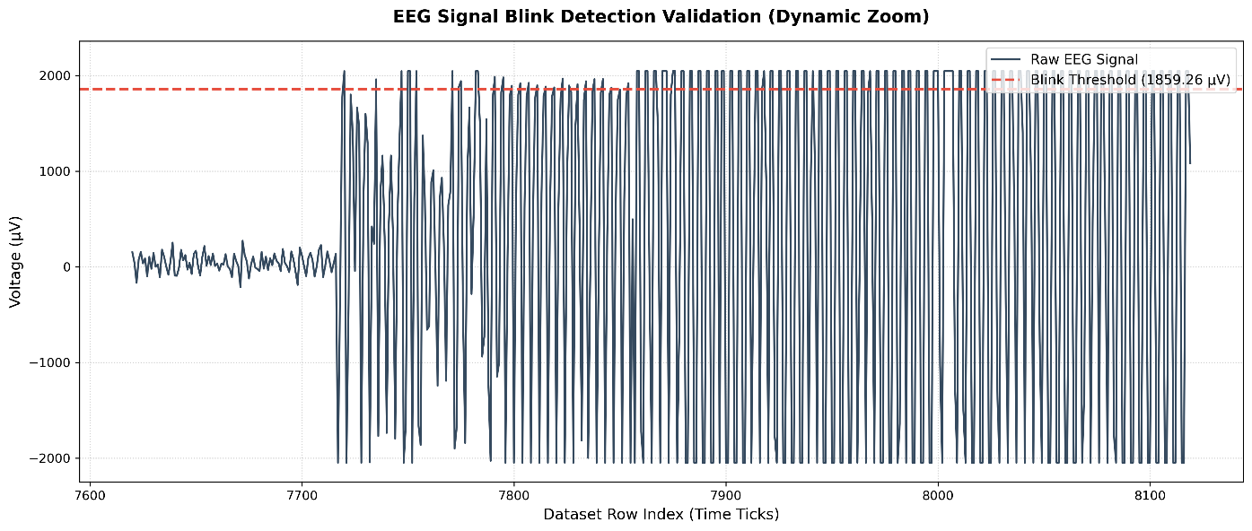
The dynamic tracking script isolated a specific temporal window between dataset rows 7620 and 8120 to validate the algorithm's accuracy. As displayed in Figure 1, the pipeline successfully isolated a baseline period of undisturbed cortical activity (rows 7620 to 7720) characterized by low-amplitude cognitive brainwaves ($≈20 μ\text{V}$). The physical execution of an eye blink at row 7720 appears as an abrupt, high-amplitude voltage spike that breaks cleanly through the red dashed threshold boundary. Rows 7800 to 8120 display continuous high-amplitude voltage oscillations reaching the hardware saturation limits of $+2000 μ\text{V}$ and $-2000 μ\text{V}$, confirming prolonged ocular muscle movement or minor headset displacement.
[Figure 1: EEG Signal Blink Detection Validation (Dynamic Zoom)]
B. Ocular Dynamics: Material Complexity vs. Personal Confusion
Analyzing the behavioural shifts across the two experimental partitions revealed that external material difficulty and internal confusion produce diametrically opposed physical reactions:
- Objective Complexity: When students transitioned from fundamentally simple introductory videos to highly dense, complex videos, their eye-blink frequency experienced a $+12.90\%$ increase relative to baseline. This upward shift corresponds to elevated cognitive load, visual scanning demands, and physical eye fatigue.
- Subjective Confusion: When analyzing rows isolated exclusively by self-reported misunderstanding, the blink rate experienced a severe drop of $-24.92\%$ from baseline.
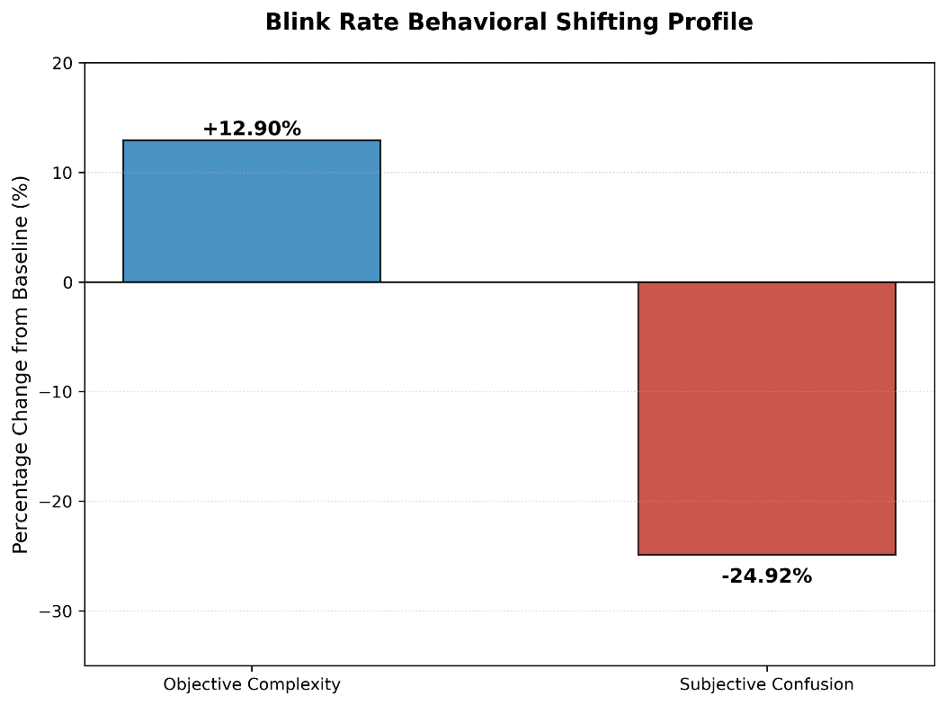
As visualized in the dual bar chart in Figure 2, this striking behavioural contrast proves that internal confusion suppresses the natural physical blinking reflex in a way that standard material difficulty does not.
[Figure 2: Blink Rate Behavioural Shifting Profile]
C. Cognitive Mapping of the Subjective Confusion Timeline
To determine what mental state was driving the severe $-24.92\%$ drop in blinking during periods of personal confusion, the isolated timeline of $6,567$ data points was evaluated using the headset’s internal attention and meditation matrices.
The evaluation rejected Hypothesis A (Active Focus) in favour of Hypothesis B (The Passive Disengagement Hypothesis). The mathematical breakdown of the timeline revealed:
- Active Focus (High Attention): Occupied only $16.22\%$ of the total confusion timeline.
- Blanking Out (High Meditation): Occupied $27.97\%$ of the total confusion timeline.
- Neutral Baseline State: Occupied the remaining $55.81\%$ of the timeline.
As represented in the pie chart in Figure 3, these distributions demonstrate that when a student is actively experiencing subjective confusion, they are more likely to enter a passive, unblinking "blank stare" state of mental disengagement as they are to maintain active, high-concentration focus.
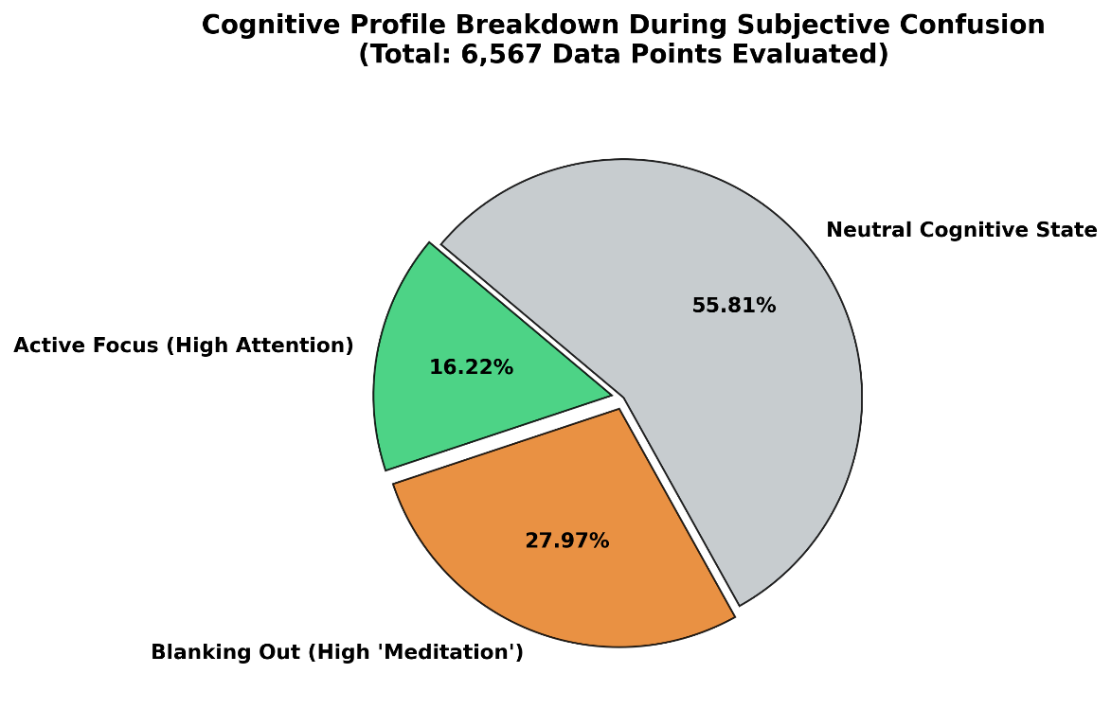
[Figure 3: Cognitive Profile Breakdown During Subjective Confusion]

- Discussion and Conclusion

A. The "Blanking Out" Phenomenon
The empirical findings of this study provide critical clarity regarding how internal cognitive strain manifests in electronic learning environments. By establishing a dual-axis framework, this paper successfully decoupled the physiological markers of external material difficulty from personal, subjective misunderstanding.
The $+12.90\%$ increase in blink frequency during structurally complex video segments aligns perfectly with classic cognitive load theory. When material is intentionally challenging, students exhibit active visual and mental processing, resulting in ocular fatigue and subsequent blinking spikes.
Conversely, the severe $-24.92\%$ drop in blinking during self-reported confusion points to a deep split between two entirely different internal mental states:
- The Active Focus State ($16.22\%$): In a minority of confused intervals, students successfully maintain high concentration. Their brainwaves reflect a high-attention Beta profile as they actively wrestle with the material. In this state, the drop in blinking is driven by intense, localized cognitive strain as the student aggressively focuses their eyes and mind on the screen to process the difficult data.
- The Blanking Out State ($27.97\%$): In the dominant portion of the confusion timeline, the physiological profile shifts entirely. Physiologically, a high meditation score reflects an elevation in Alpha and Delta brainwave frequencies. In an academic context, this indicates that the brain's active computational nodes have effectively stalled or entered a state of mental paralysis. The student hits an intellectual wall, ceases active data ingestion, and experiences an involuntary, unblinking zone-out state.
By demonstrating that the high-meditation "blanking out" state is more dominant over active focus, our data definitively rejects the hypothesis that confusion simply causes a student to study harder. Instead, it proves that subjective confusion is primarily a state of passive cognitive disengagement.
B. Application and Limitations
These insights show why ed-tech platforms cannot rely on basic tracking metrics; assuming that a drop in blinking always means "intense focus" will completely misinterpret a struggling student. By embedding an automated threshold pipeline, future software can monitor raw data streams in real time. If a system detects a prolonged drop in blinking alongside falling attention scores, it can dynamically intervene, pausing the video or offering a simplified breakdown to break the student's physical blank stare.
However, we must note that our consumer-grade hardware is prone to sensor saturation. Muscle movements like jaw clenches or headset shifts frequently overwhelmed the sensor, causing the flat-line signal clipping at the $±2000 μ\text{V}$ limits in our plots.
C. Summary
This study successfully constructed an automated blink-detection architecture to map the physical and mental realities of student confusion. Our results prove that true personal confusion triggers a state of passive cognitive disengagement rather than an intensification of effort. By demonstrating that single-channel consumer hardware can cleanly isolate these states, this work lays a foundational stepping stone toward building more intuitive, adaptive, and human-centric educational technologies.

- References

[1] Marquart, G., Cabestrero, R., & De Waard, D. (2015). Eyelid movements as an indicator of cognitive workload. Frontiers in Psychology, 6, 889.
[2] Recarte, M. A., & Nunes, L. M. (2000). Effects of verbal and spatial-imagery tasks on eye fixations and saccades during driving. Journal of Experimental Psychology: Applied, 6(1), 31.
[3] Wang, H., Li, Y., Hu, X., & Zhang, Y. (2013). Using EEG to Predict Student Confusion on MOOCs. In Proceedings of the 6th International Conference on Educational Data Mining (EDM), 340-341.

